Fura 2 Analysis Program Instructions  
  
**Installation**

1. Extract the zip file to your computer.
2. Open the extracted folder and navigate to the fura2 folder.
3. In the fura2 folder, there is a program called fura2.exe. Double click to start it.
4. You might need to give explicit permission to run the program because it is from an unrecognized developer.

**Batch Analysis**

Figure 1: Initial Window when running Fura2 Program

1. The program will prompt you to choose the number of experimental groups to analyze. Press submit and the window should populate.
2. Enter an identifier for the experimental group in the text box next to “Name” and press submit.A screenshot of a group

   Description automatically generated with medium confidence

Figure 2: Window to set LP parameters and analyze an experimental group

1. A new window will pop up with options to manually enter the parameters (Enter LP#) or load a parameter file (Load Parameter File). The title in the window will correspond to the name entered in the last window.
2. Manually Entering Parameters
   1. Next to “Enter LP #” type in the number of liquid periods in your experiment.
   2. Once you press submit, the window will populate with boxes for each LP. In Figure 3, there are 3 LPs.
   3. For each LP, fill out the parameters according to the experiment.
      1. Name: Identifier for the LP
      2. Duration: Duration of the LP in minutes
      3. Measurement: Choose the Mean, Min, or Max depending on what measurement you want to examine for the LP
      4. Threshold: Check this box if you want to compare the measurement (mean, min or max depending on what’s checked above) to a threshold value
      5. Ratio & DR/R: Check ratio if you want to compare the ratio of 340/380 to a threshold, check DR/R if you want to compare the ∆R/R to some threshold
      6. > & < : Choose to compare if the value is less than (<) or greater than (>) some threshold
      7. Textbox: enter the value for the threshold
      8. ROI Select: check this box if the threshold comparison will determine if the ROI is included in the final analysis
         1. This can be selected for multiple LPs. Only ROIs that pass the threshold for ALL “ROI Select” LPs will be included in the full analysis
      9. Example: In Figure 3, we have three LPs shown: Baseline, Osm, and Test. Baseline is 1 minute. For the baseline LP, mean response is calculated. If the mean ratio (340/380) in this LP is less than 1 for an ROI, then it has passed the threshold. If “ROI Select” was checked, only ROIs that meet this threshold will be included in the final analysis. Since it isn’t, then cells that have a 340/380 value over 1 are also included.

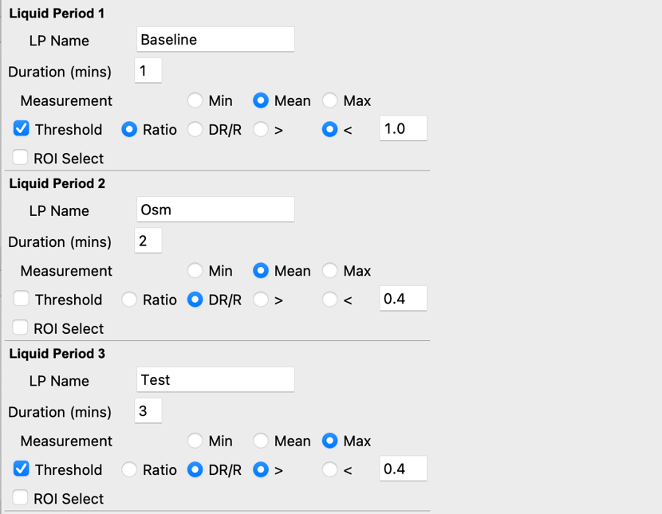

Figure 3: Example of how to set up the parameters of an experiment

* 1. Once you’ve filled out the whole parameters, you can save it to your computer for easy regeneration of the same analysis by pressing “Save Current Parameters.”

1. Loading parameters
   1. Press “Load Parameter File” and select an excel file previously generated using this program. It should automatically populate the LPs.
2. Load Files
   1. Press load files to import .LOG files
   2. You can select a single .LOG file or multi-select many files. All files should have the same exact parameters as indicated for each LP.
   3. Multi-select will generate an analysis that concatenates all ROIs across the .LOG files into a single analysis.
3. Calculate Responses
   1. Pressing ‘Calculate Responses’ will generate three tables.
      1. The first table “Responsive Data” has rows for each LP that had ‘Threshold’ checked and filled out.
         1. Count: Gives a total number of ROIs in the analysis that meet the threshold for each LP
         2. Percent: Percent of ROIs that meet the threshold.
         3. Ratio: The average value of the response for all ROIs that meet the threshold for the LP. For example, in Figure 4, 0.58 is the “Ratio” value for the “Test” LP. This is the average value of the max 340/380 value for all 6 ROIs that passed the threshold of > 0.4.
         4. Ratio SEM: SEM of the values averaged in iii
         5. Delta R: same as ratio but with the ∆R/R values
         6. Delta R SEM: SEM of values averaged in vi.
      2. Summary Stats: Ratios: This table determines the mean, median, standard deviation, SEM, Min, and Max across ROIs. For each ROI, the metric set in the LP frame will be calculated (i.e. mean for baseline, max for Test, see Figure 3)
         1. Note: only cells that meet the thresholds for all “ROI Select” conditions are included. If “ROI Select” is not selected for any LP, all ROIs are included.
      3. Summary Stats: Delta. This table has the same logic as the table above, but calculates the values of the ∆R/R values

Figure 4: Calculate Responses Output

1. Save Responses: This button will save the data in an excel sheet. You can choose the filename and location. Default filename is the name of the experimental group/file.
   1. If you selected multiple .LOG files, the program will generate an excel file with ROIs across all .LOG files concatenated together. It will also save individual excel files for each .LOG file.
   2. Excel sheet output: The resulting excel will have many sheets
      1. ROI Information: If the .LOG file had header information, it will be included here. If not, this sheet will not be included
      2. Raw Data: This sheet is equivalent to the data in the main part of the .LOG file
      3. Ratio Data: This sheet has columns indicating the timepoints for each row as well as its corresponding LP. The numbered columns are ROIs containing the 340/380 values.
      4. Ratio Data – Resp: This sheet is the same as Ratio Data, but only includes the ROI that meet the threshold for all “ROI Select” LPs
      5. Delta R over R: This is the ∆R/R for each ROI. The ∆R/R is calculated with respect to the first LP.
      6. Delta R over R – resp: same as above with “ROI select” ROIs only
      7. Responsive Data: Same table as presented when pressing “calculate responses”
      8. Responsive Ratios: Same table as “summary stats: ratios” presented when pressing “calculate responses”
      9. Responsive Delta Rs: Same table as “summary stats: delta” presented when pressing “calculate responses”
      10. Metric Ratios: Gives the metric (min, mean, or max) of the 340/380 value for each LP for every ROI.
      11. Metric Ratios – resp: Same as above for “ROI select” ROIs
      12. Metric Delta R: Gives the metric (min, mean, or max) of the ∆R/R value for each LP for every ROI.
      13. Metric Delta R – resp: Same as above for “ROI select” ROIs
      14. Responsive: True or False for each ROI for each LP to indicate if its passed the LP’s threshold. Includes a column to indicate “Good ROIs” which are ROIs that pass threshold for all “ROI select” LPs
2. Plot Data
   1. This button will first generate a window for you to set the y limits for plotting the 340/380 plots (ratio) and the ∆R/R plots (delta). If left as 0’s, it will just automatically set limits to fit the data. Limits can be set to match the y axis across different experiments easily.
   2. If average is left unchecked, each ROI will be plotted separately. If checked, an average with SEM will be plotted instead.
   3. Pressing submit should generate the plots. The “Input y axis limits” window can then be exited out of.

1. Once you’ve analyzed the experimental group, you can exit out of the main window (Figure 2). Don’t exit out of the first window (i.e. Figure 1) until completely finished.
   1. Note: Be sure to press “Calculate responses” before closing if you want the data generated for the group analysis.
   2. Note: Be sure to save in this window if you want the individual excel sheets generated for the analysis.
2. Comparing multiple experimental groups
   1. Once you’ve completed analysis for each group in your main window (i.e. Figure 1), you can generate group analyses
   2. Calculate Group Metrics: This button will generate the same tables as “calculate responses” but for each experimental group.
   3. Plot Groups: This plots the average trace for each experiment on one plot. In order for this to look correct, each experimental group needs to have the same LPs. Figure 5 shows an example plot.
   4. Save Data and Plots: This will save all the plots and the excel file
      1. Excel Sheets correspond to the output of calculate group metrics with separate sheets for each experimental group.
         1. Responsive Data
         2. Ratio Metrics
         3. Delta Metrics

Figure 5: Example group plot